實際實驗:

source:

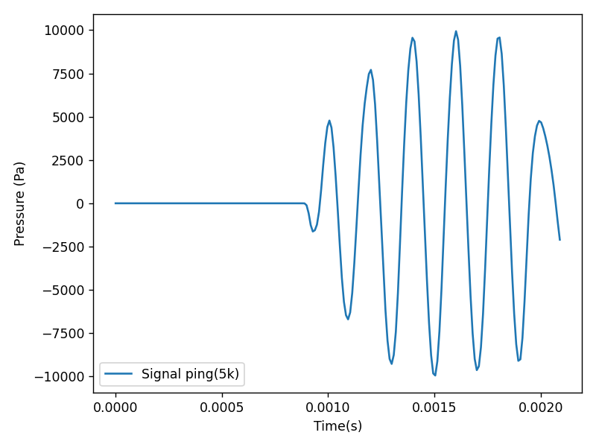

received signal:

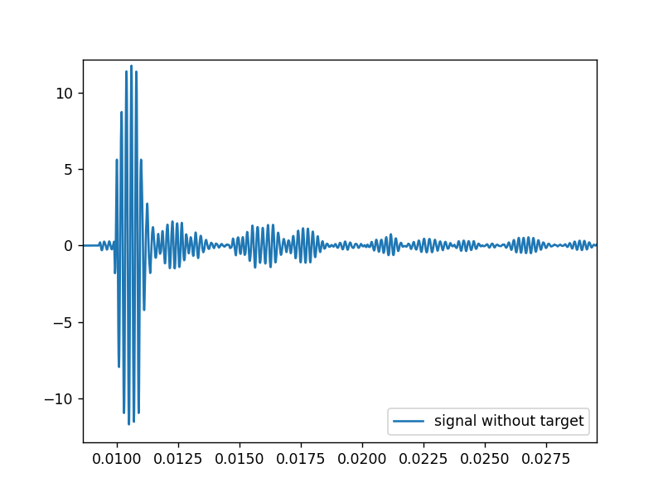

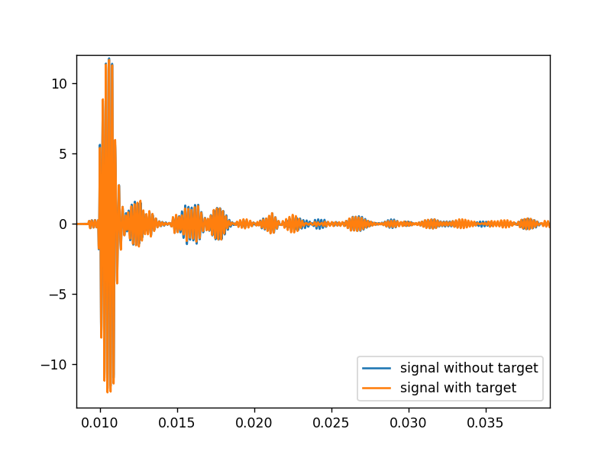

Matched filter 模擬後處理

聲源: fs=102400, 5kHz, 6 cycles, hann windowed

signal duration = 0.0012

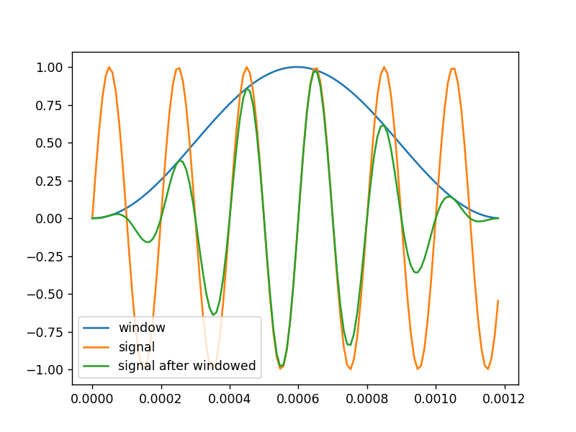

time_delay_1 = 0.003

time_delay_2 = 0.0035

alpha_1 = 0.5

alpha_2 = 0.1

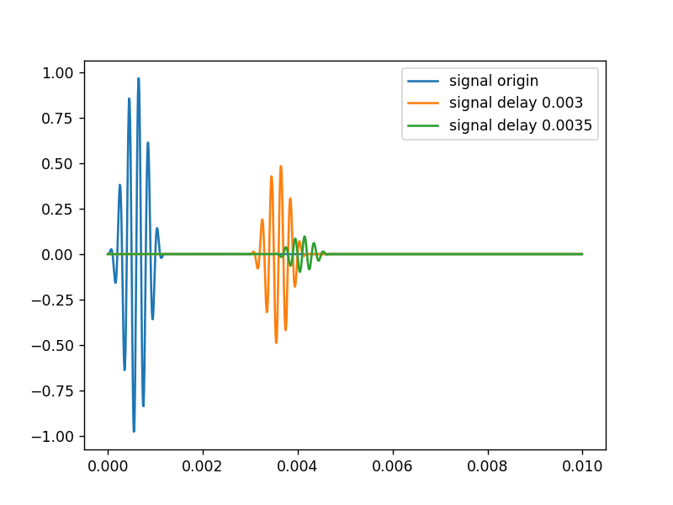

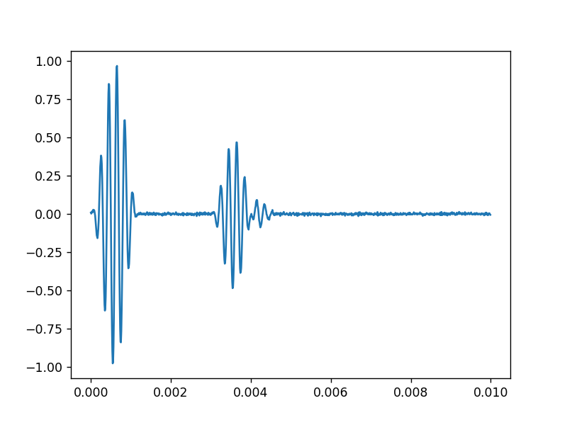

Applying matched filter:

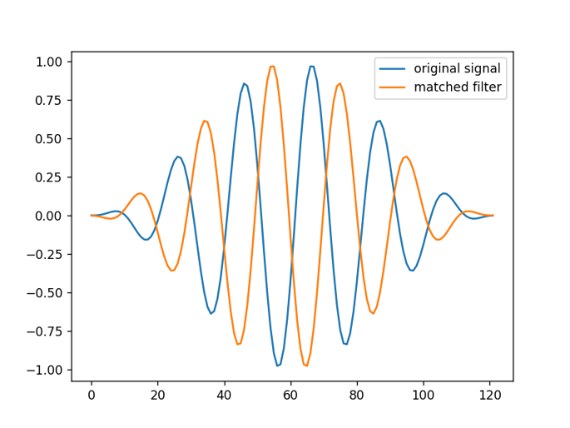

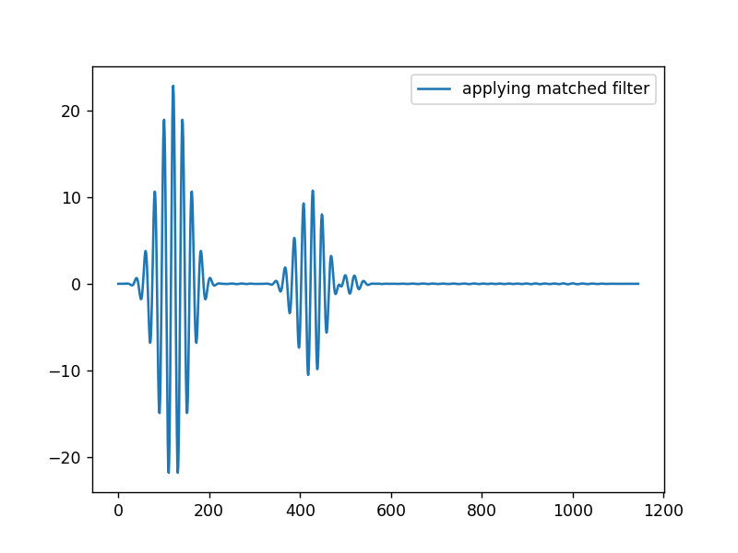

發現

* 由於聲源有重複性的五個cycles, 波形過於重複性，matched filter 的值也同樣有週期性
* 若波形重疊，振幅會相互抵消，聲源特徵消失，導致match 步到。

Auto-correlation:

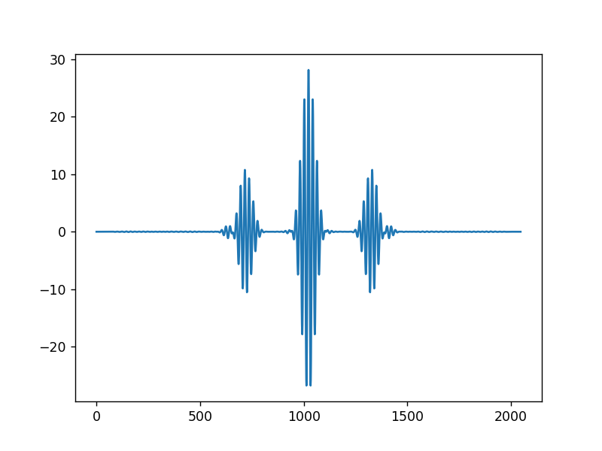

認為:

聲源不夠具有特徵

更改聲源為3000 ~10000 chirp, duration time=0.001

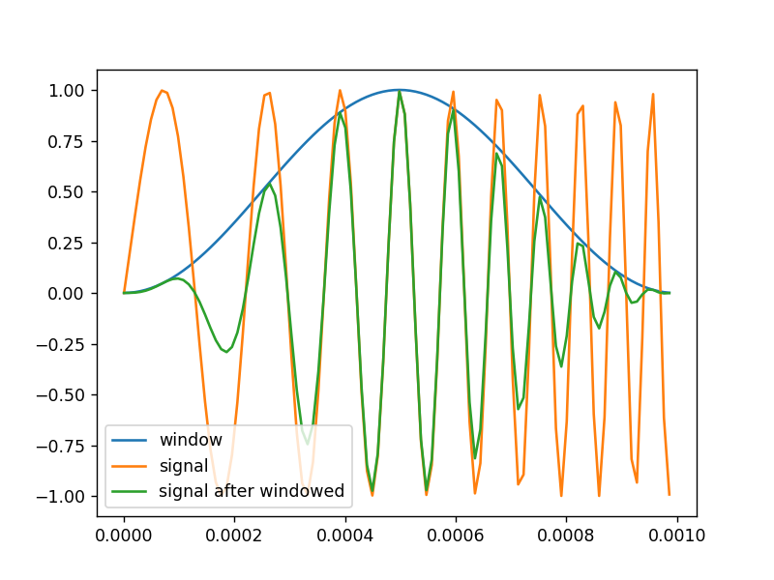

source:

time_delay_1 = 0.002

time_delay_2 = 0.0025

alpha_1 = 0.5

alpha_2 = 0.1

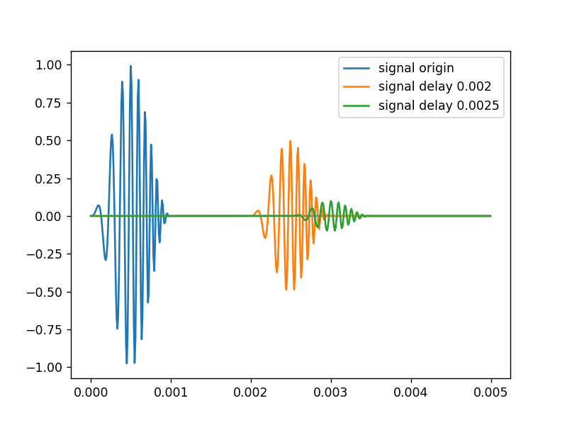

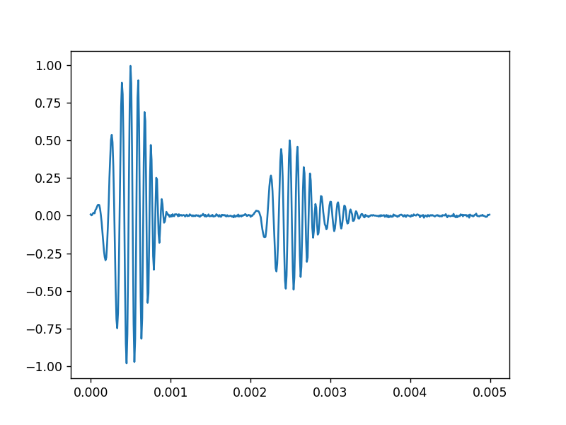

Applying matched filter:

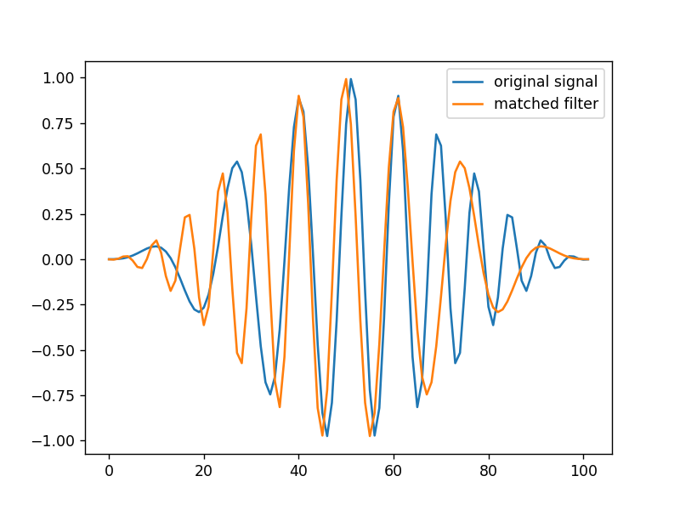

after applying matched filter:

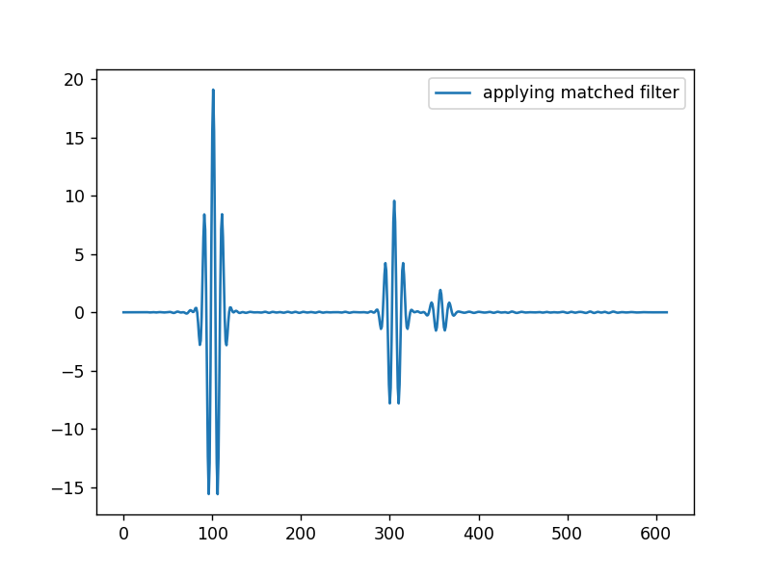

get time delay:

processed time delay_1 error: -7.812500000000007e-06

processed time delay_2 error: 0

still not get the alpha

Autocorrelation:

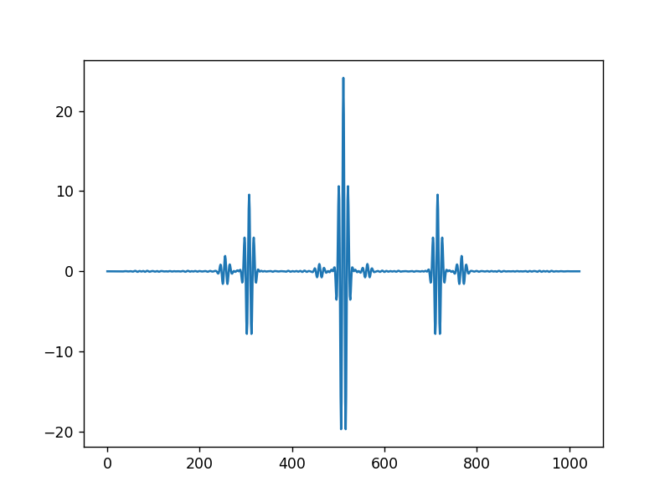

多小的訊號時間差我可以分割出來

想法: matched filter 本身 autocorrelation 的訊號不要重疊即可

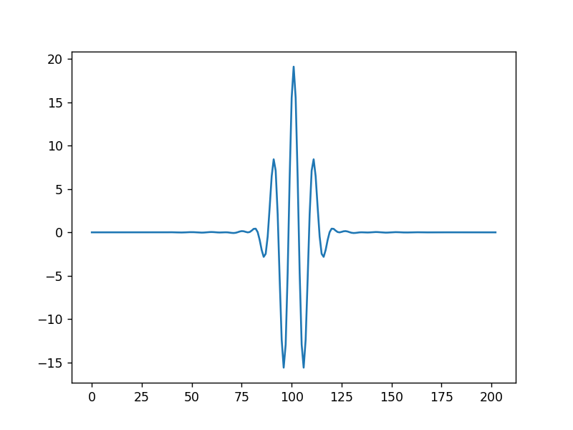

持續時間:

0.000376298828125

Test 想法:

time_delay_1 = 0.002

time_delay_2 = 0.00238

alpha_1 = 0.5

alpha_2 = 0.1

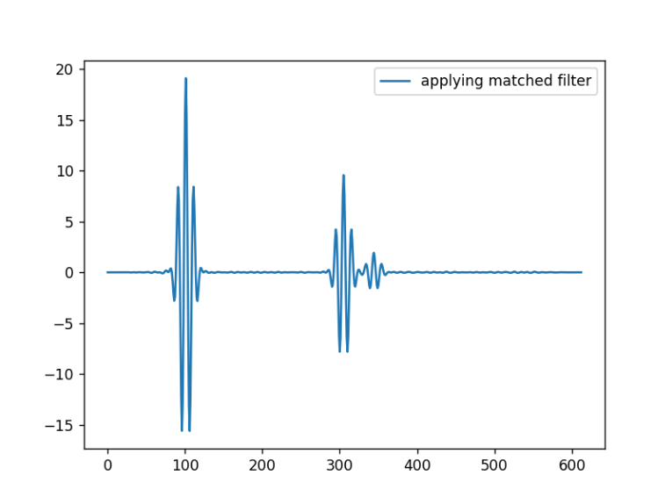

Conclusion:

source: 3000~10000 chirp, 持續時間: 0.001s

設計實驗訊號延遲差大於0.00038s以上，也就是0.38ms

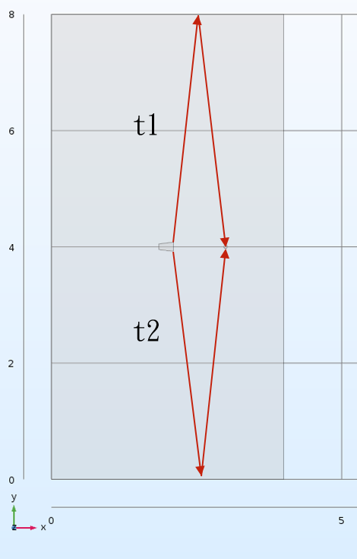

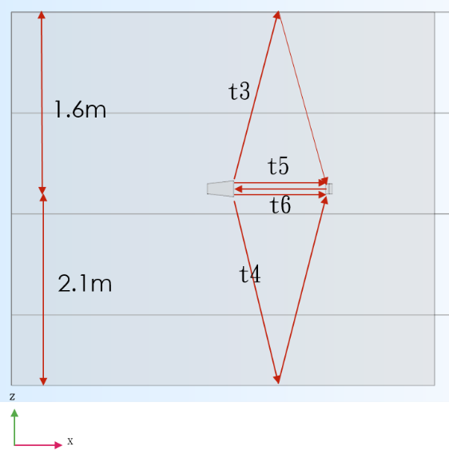

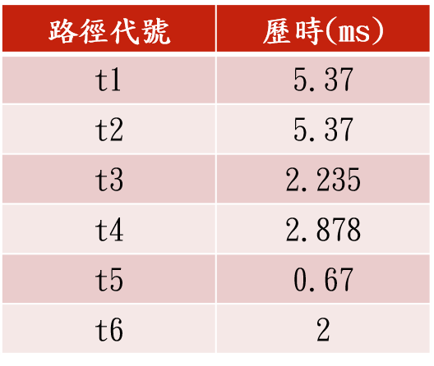

改水下1.8m: 0.00249s

|  |  |
| --- | --- |
| 路徑代號 | 歷時(ms) |
| T1 | 5.37 |
| T2 | 5.37 |
| T3 | 2.49 |
| T4 | 2.6841 |
| T5 | 0.67 |
| T6 | 2 |

規劃實驗:

2020_07_04星期六

1. 改水下1.8m
2. staroddi 設定
3. source 量測。包括實驗重複性&聲源duration time

待解決: 由示波器產生自定義波形